EXPERIMENT 2
REAL-TIME STREAM ANALYTICS AND ANOMALY DETECTION USING NODE-RED AND MQTT (GOOGLE COLAB VERSION)

Aim
To design and implement a real-time stream analytics system using MQTT protocol and perform anomaly detection on sensor data. Google Colab is used for MQTT communication, stream visualization, and anomaly detection.
Objective
- Generate real-time iot sensor data.
- Publish sensor values using MQTT.
- Subscribe to MQTT messages.
- Detect abnormal values.
- Display live graphs.
- Store data for future analysis.
Software required
- Google Colab
- Python 3
- Mosquitto MQTT Broker (public broker)
- paho-mqtt
- pandas
- matplotlib
- numpy
Theory
MQTT (Message Queuing Telemetry Transport) is a lightweight messaging protocol widely used in IoT applications.
Publisher → MQTT Broker → Subscriber
Node-RED usually acts as a subscriber and dashboard. In Google Colab we simulate Node-RED functionality using Python.
Sensor data example:
Temperature , Humidity

Analytics:
- Moving Average
- Mean
- Standard Deviation
Anomaly Detection:
If
Temperature > 35°C
OR
Temperature < 15°C
then
Anomaly = TRUE
Algorithm
- Start the program.
- Connect publisher to MQTT broker.
- Generate random temperature and humidity values.
- Publish sensor data every second.
- Subscriber receives MQTT messages.
- Store incoming data.
- Calculate statistical measures.
- Check for abnormal values.
- Display anomalies.
- Plot real-time graphs.
- Repeat continuously.
Code
import random
import time
import queue
import threading
import pandas as pd
import numpy as np
import matplotlib.pyplot as plt
from IPython.display import clear_output

# Simulated MQTT Queue (Broker)
mqtt_broker = queue.Queue()
speed_data = []
time_data = []
# ---------------- Publisher ----------------
def publisher():
for i in range(30):
speed = random.randint(40, 120)
mqtt_broker.put(speed)
time.sleep(1)
# ---------------- Subscriber ----------------
def subscriber():
while len(speed_data) < 30:
if not mqtt_broker.empty():
speed = mqtt_broker.get()
speed_data.append(speed)
time_data.append(len(time_data)+1)
mean = np.mean(speed_data)
std = np.std(speed_data)
if len(speed_data) >= 5:
moving = np.mean(speed_data[-5:])
else:
moving = mean
if speed > 100:
status = "ANOMALY"
else:
status = "NORMAL"
clear_output(wait=True)
print("========== VEHICLE SPEED MONITORING ==========\n")
print("Current Speed :", speed, "km/h")
print("Mean Speed :", round(mean,2))
print("Std Deviation :", round(std,2))
print("Moving Average:", round(moving,2))
print("Status :", status)
plt.figure(figsize=(10,4))
plt.plot(time_data, speed_data, marker='o', linewidth=2)
plt.axhline(80,color='green',linestyle='--',label="Normal")
plt.axhline(100,color='red',linestyle='--',label="Anomaly")
plt.xlabel("Reading")
plt.ylabel("Speed (km/h)")
plt.title("Real-Time Vehicle Speed Monitoring")
plt.legend()
plt.grid(True)
plt.show()
publisher_thread = threading.Thread(target=publisher)
subscriber_thread = threading.Thread(target=subscriber)
publisher_thread.start()
subscriber_thread.start()
publisher_thread.join()
subscriber_thread.join()
df = pd.DataFrame
({
"Reading":time_data,
"Speed(km/h)":speed_data
})
df.to_csv("vehicle_speed_data.csv",index=False)

print("\nExperiment Completed Successfully")
print("CSV File Saved: vehicle_speed_data.csv")
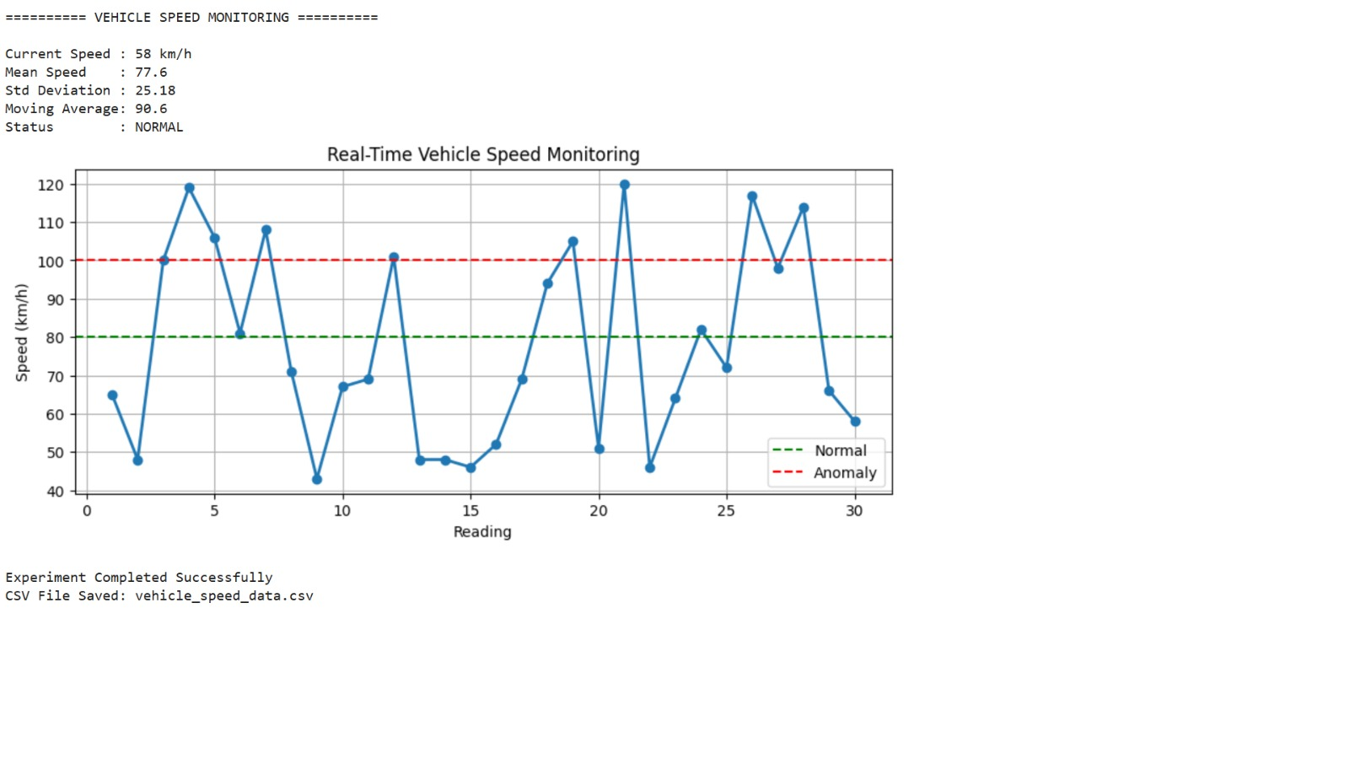

Result
The real-time IoT stream analytics system successfully generated sensor data, transmitted it through the MQTT broker, received it using a subscriber, performed stream analytics, detected abnormal temperature values, and visualized the results in Google Colab. The experiment demonstrates how MQTT-based IoT systems can be integrated with Python for real-time monitoring and anomaly detection without requiring a local Node-RED installation.

